**Candidate Name:**

**Method or job site used to reach this form:**

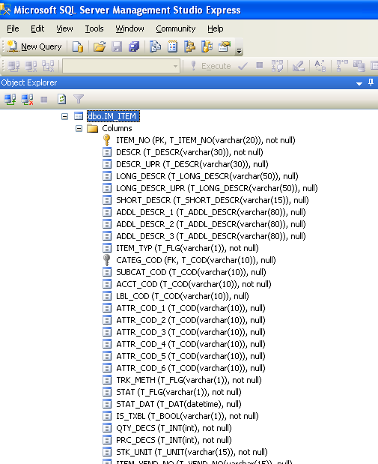

Using the screen shot above, please answer the following questions:

1. What is the column name of the primary key for the table?
2. The Primary Key is, of course, indexed. What other column(s) are indexed on this table?
3. Circle which of the following are valid values for PRC_DECS (expect to circle more than one):

128 3.28 -5 2 Y Green $&#*@( (5)

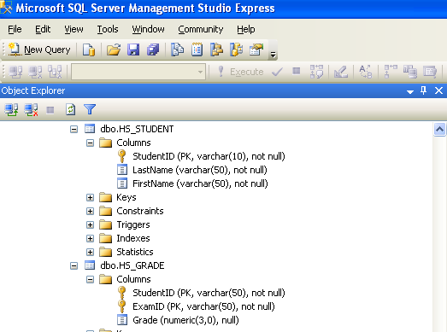

Please write a SQL query that will remove all students from the database who have a last name of “Jones”

Please write a SQL query that will provide the average exam grade for each student in the database and order the list by the student’s last name.

The following question is more functional than technical. Please populate the tables below with columns that you would commonly expect to see in a business purchase order application. You need not fill every line available. Just fill the table with columns that you believe are reasonable to expect. For each column that you designate, please provide a column name and your suggested data type. Lastly, indicate which columns constitute the primary key:

|  |  |  |
| --- | --- | --- |
| ORDER_HEADER |  | ORDER_LINE |
|  |  |  |
|  |  |  |
|  |  |  |
|  |  |  |
|  |  |  |
|  |  |  |
|  |  |  |
|  |  |  |
|  |  |  |
|  |  |  |
|  |  |  |
|  |  |  |
|  |  |  |
|  |  |  |
|  |  |  |
|  |  |  |